Superior University Gold Campus
Lab Task 4
Artificial Intelligence Lab
Name: Tasawar Hussain
Roll no: SU92-BSSEM-F24-073
1. Objective & Problem Statement
The goal is to implement and analyze the $A^{*}$ search algorithm using heuristic evaluation functions $f\left(n\right)=g\left(n\right)+h\left(n\right)$ for spatial pathfinding. We evaluate $A^{*}$'s efficiency, optimality, and node expansions against Uniform Cost Search (UCS) and observe the effect of violating heuristic admissibility.
2. Task 1: Manual Frontier Trace & Heuristic Audit
Graph & Heuristic Setup
- Start: $S$ | Goal: $G$
- True Remaining Costs ($h^{*}$): $S:6$, $A:5$, $B:5$, $C:3$, $G:0$
- Supplied Heuristic ($h$): $S:5$, $A:4$, $B:4$, $C:2$, $G:0$
- Admissibility Verification: Since $h\left(n\right)≤h^{*}\left(n\right)$ for all nodes, the heuristic is admissible.
First 3 Node Expansions
- Expansion 1 (Node $S$):
  - Selected: $S$ | $g\left(S\right)=0,h\left(S\right)=5,f\left(S\right)=5$
  - Successors added: $A\left(g=1,h=4,f=5\right)$, $B\left(g=4,h=4,f=8\right)$
  - Frontier: $\left[\left(A,f=5\right),\left(B,f=8\right)\right]$
- Expansion 2 (Node $A$):
  - Selected: $A$ | $g\left(A\right)=1,h\left(A\right)=4,f\left(A\right)=5$
  - Successors added: $C\left(g=3,h=2,f=5\right)$
  - Frontier: $\left[\left(C,f=5\right),\left(B,f=8\right)\right]$
- Expansion 3 (Node $C$):
  - Selected: $C$ | $g\left(C\right)=3,h\left(C\right)=2,f\left(C\right)=5$
  - Successors added: $G\left(g=6,h=0,f=6\right)$
  - Frontier: $\left[\left(G,f=6\right),\left(B,f=8\right)\right]$
- Next node selected: $G$ ($f=6<f\left(B\right)=8$). Goal reached with optimal cost 6.
3. Task 2: $A^{*}$ vs UCS Controlled Comparison
Search Algorithm | Heuristic Used | Returned Path | Path Cost | Expanded Nodes
$A^{*}$ Search | Admissible $h\left(n\right)$ | $$S→A→C→G$$ | 6 | $$\left[S,A,C\right]$$
UCS Control | $$h\left(n\right)=0$$ | $$S→A→C→G$$ | 6 | $$\left[S,A,B,C\right]$$
Analysis: Both algorithms find the optimal path of cost 6, but $A^{*}$ expands fewer nodes because the heuristic guides the search toward the goal, avoiding unnecessary expansion of node $B$.
4. Task 3: Overestimate & Admissibility Violation Experiment
- Modified Value: $h\left(C\right)$ changed from $2$ to $10$ (True cost is 3, so $10>3$, violating admissibility).
- Result:
  - Returned Path: $S→B→G$
  - Path Cost: 9 (Sub-optimal!)
  - Expanded Nodes: $\left[S,A,B\right]$
- Explanation: Overestimating $h\left(C\right)$ artificially increases $f\left(C\right)$ to $3+10=13$. As a result, $A^{*}$ prunes/delays inspecting $C$ and incorrectly selects node $B$ ($f\left(B\right)=8$), returning a sub-optimal path of cost 9.
5. Execution Screenshots
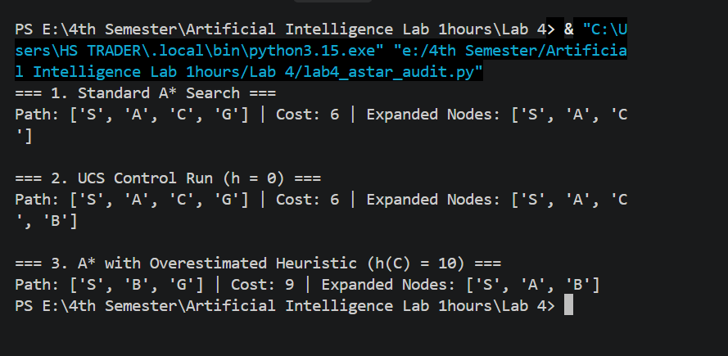6. Reflection & Conclusion
- Key Learnings: $A^{*}$ combines actual path cost ($g$) with estimated remaining cost ($h$). An admissible heuristic guarantees optimal solutions while expanding fewer nodes than UCS.
- Failure Analysis: Overestimating heuristics break optimality guarantees and cause the search to pick longer/costlier paths.

